First Year Induction Programme 2019

As per AICTE guidelines, First Year Students Induction Programme was conducted during the first half of August 2019. The induction programme was designed in a way to make newly joined students feel comfortable, motivate them towards exploring academic interests and extra-curricular activities. The two-week programme included various sessions on universal human values, literary aspects, subject introduction, creative arts, physical activities and preference-based activities. The activity-oriented learning helped first-year students to explore their potentials and further resulted in the marvellous performance on Independence Day celebration. SFIT campus tour and a visit to the nearby orphanage were arranged for our students to understand the feeling of responsibility towards oneself, one’s family, society, & nature. The life Skills session conducted by Ms Deepa Panakal was highly fruitful as commented by a student that “it answered many of my questions and doubts on life and relationship.” The value education activities conducted by class coordinators and Universal Human Values sessions by Mr M. Bysani, Mr Paul Fernandez, Ms Deepa Panakal and Mr Praveen Mathew introduced the basics of Holistic Development to our students. The interaction with faculty members and senior students made them more comfortable in the new campus environment. The positive feedback of our students towards induction program is a motivation for Basic Science and Humanities Department to organize more events in this academic year as an extension of Students Induction Programme. First-Year Students Induction Programme 2019 was a great success with the teamwork of entire FE staff under the able guidance of FE Coordinator, Dr Poonam Hemnani.
A few pics are furnished below to give you just a glimpse of the various sessions our students attended:
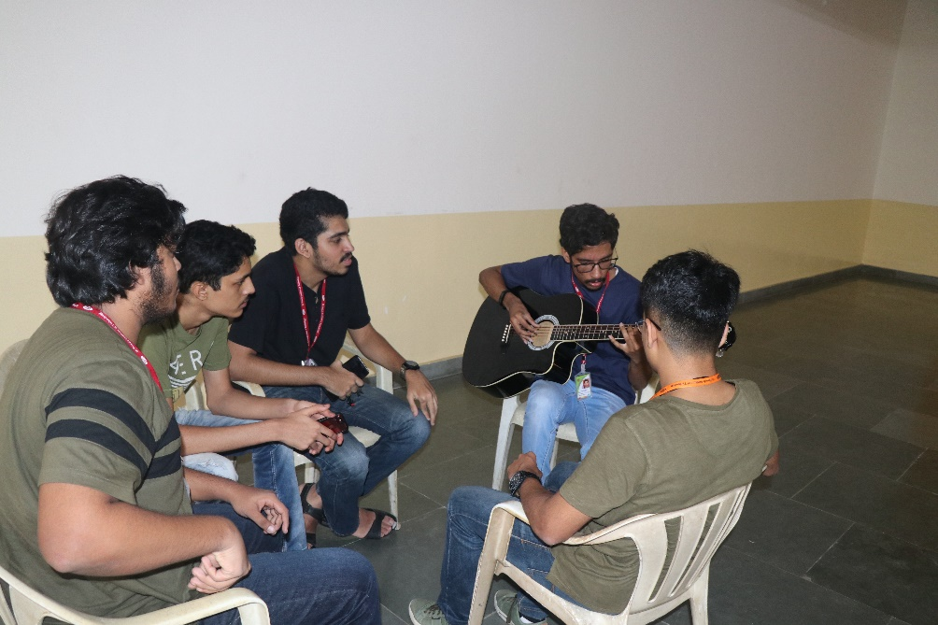
1. Playing Musical instruments
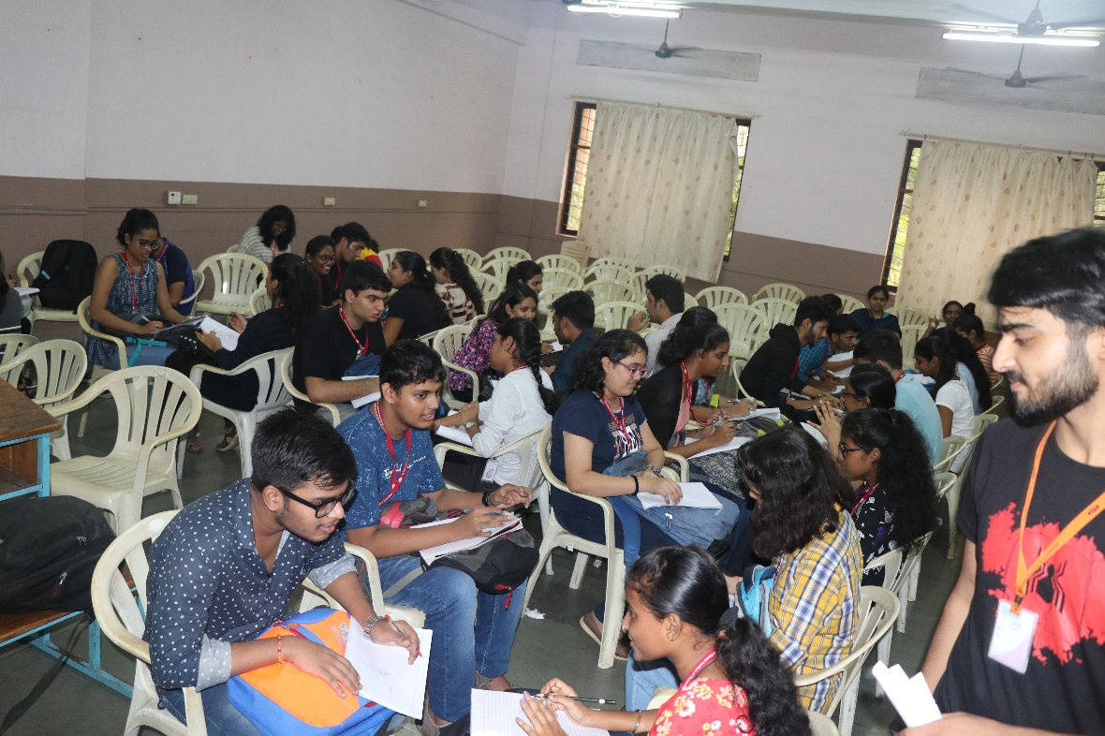
2. Creative Arts session

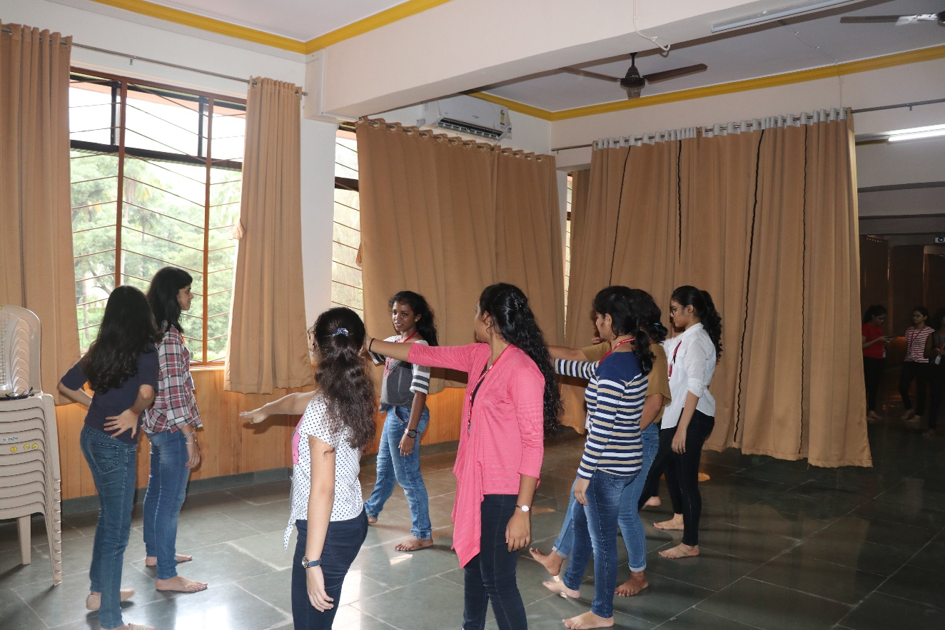
3. Performing Arts session

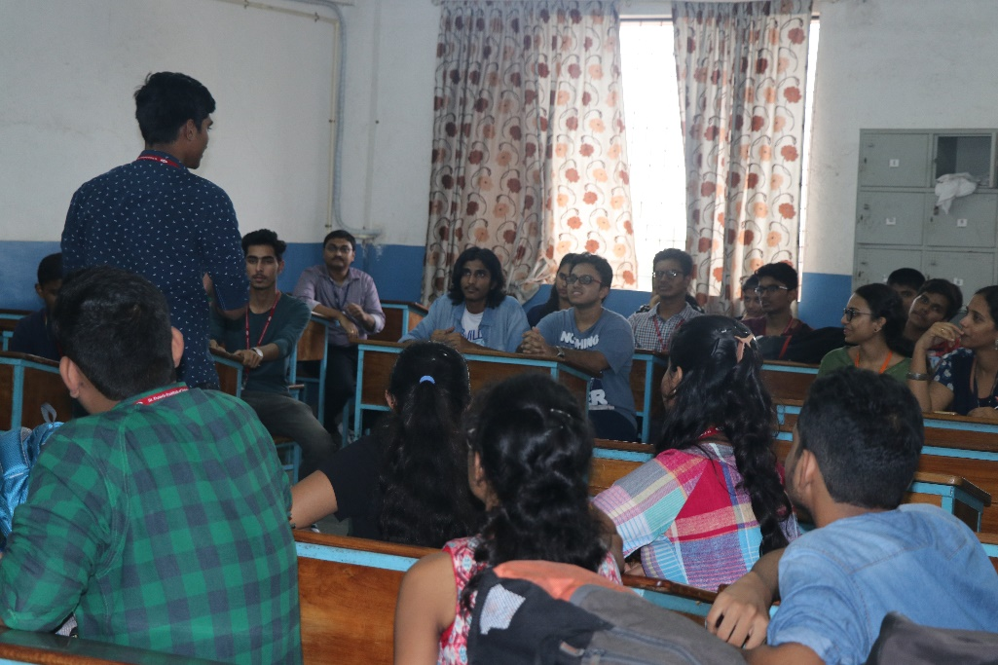
4. Session of Literary activities
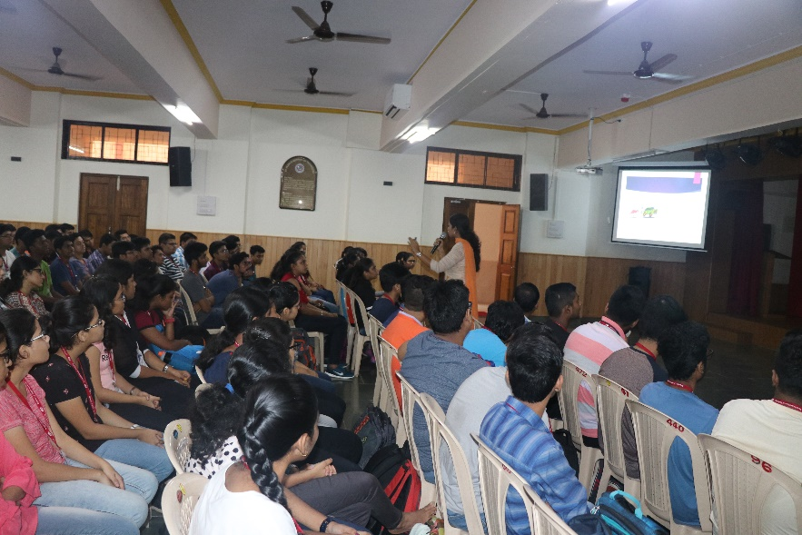
5. Session on life skills by Ms Deepa Panakkal

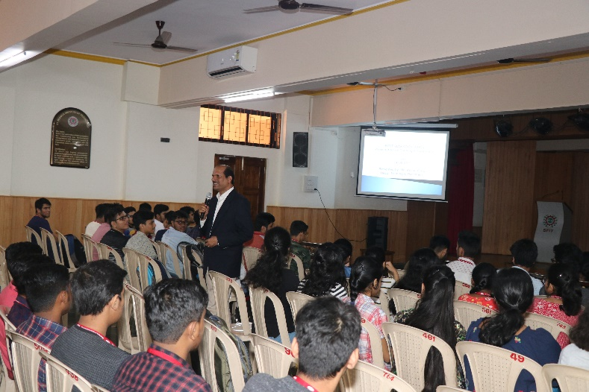
6. Session by Training and Placement officer, Mr. Wilson Pinto

Session by Mr. Albert Dsouza

Motivating and guiding students to focus and direct their energies in a manner that they truly realise their potentials.

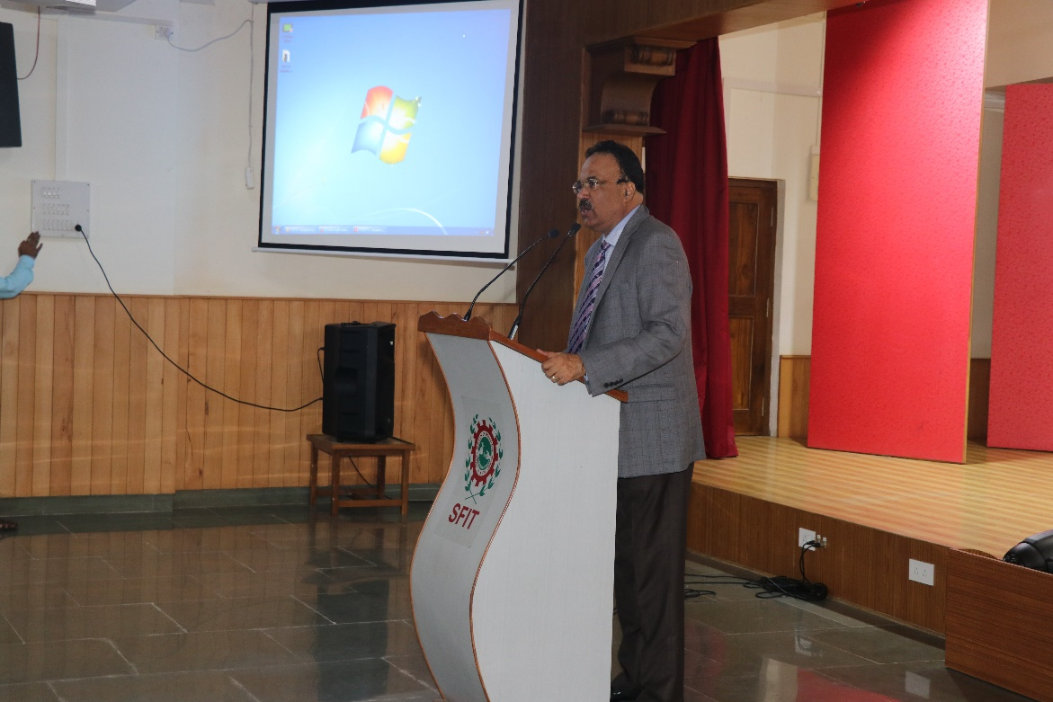
7. Session by Mr. Albert Dsouza

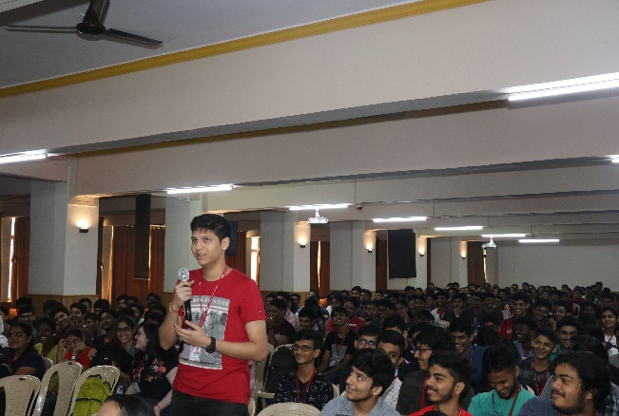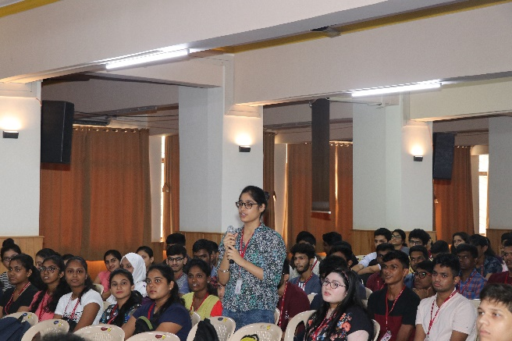
8. student participation during Sir's session

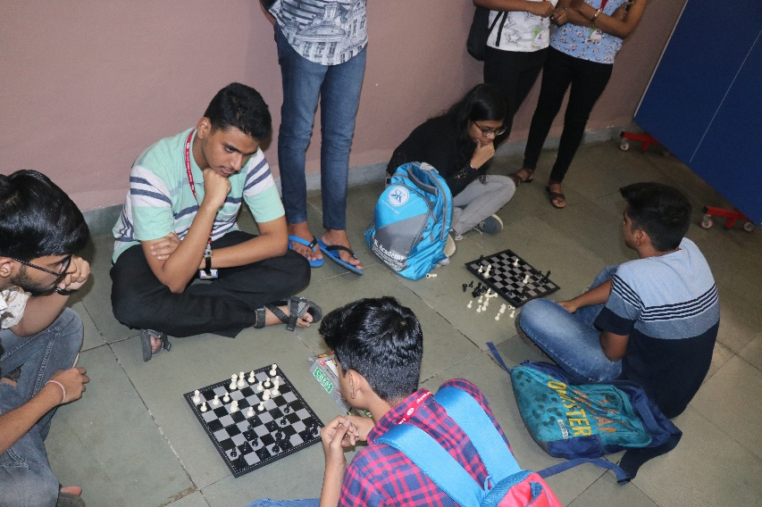
9. One of the indoor games

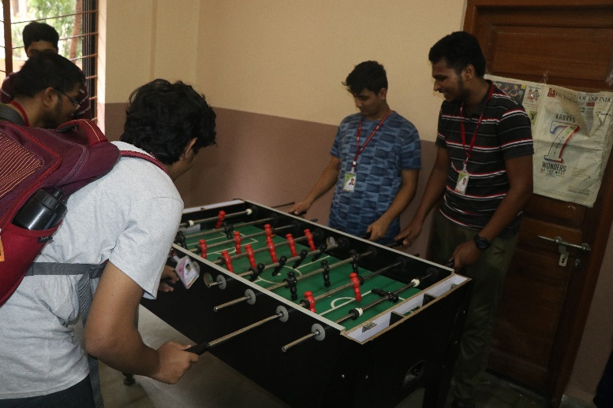
10. one more...indoor games

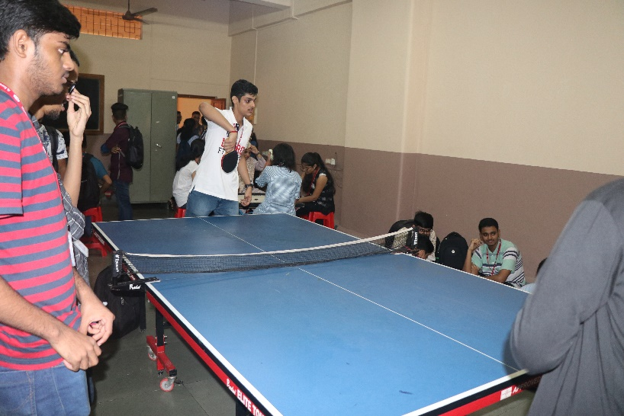
11. And one more...

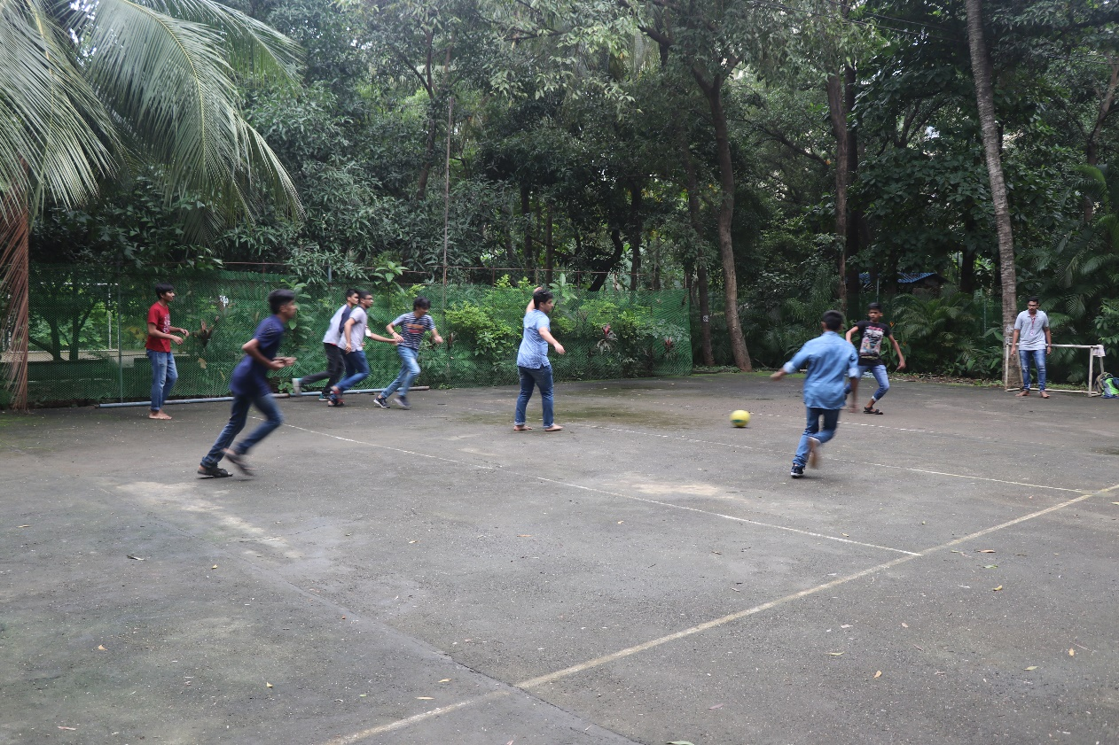
12. one of the outdoor sports

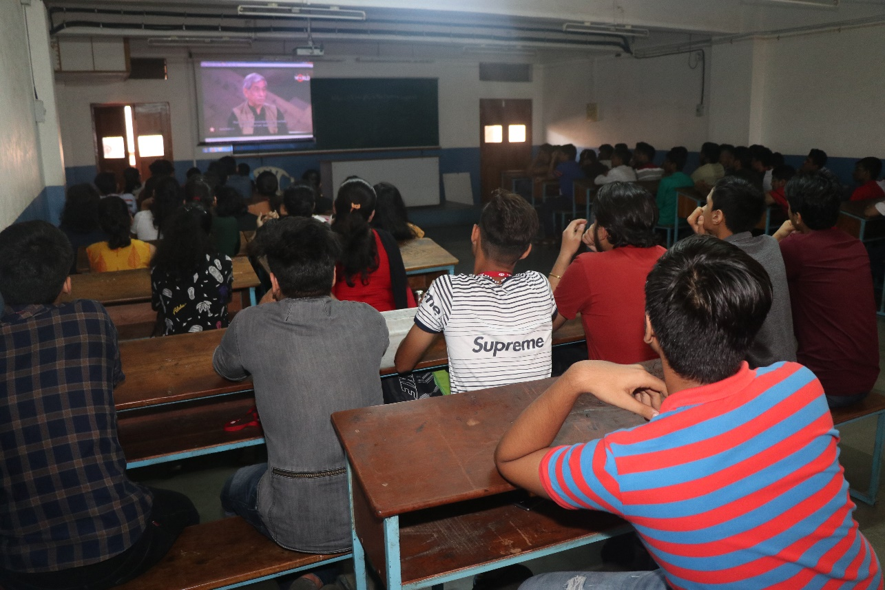
13. Movies and videos for fruitful discussion and understanding

